Name ______________________________________ Remote Learning Speech-Language Activities
above grade level
on grade level
below grade level

above grade level
on grade level
below grade level

Tic- Tac- Toe
Directions: You may choose any 3 activities to do that make a Tic-Tac-Toe. The assignments must be three in a row down, across, or diagonal. Let me know which activities you choose to do. You can take a picture of your work and send it back to me. Have fun!
Write your name three times using crayons of different colors each time. Name the colors. | Draw 5 different size circles. Turn them each into something different (sun, flower, faces). | Cut a string in three pieces of different lengths (could be tape, spaghettis, straws, grass). Sort the results by small, medium or large.
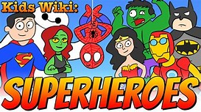  Which is your favorite superhero and tell your adult what are his/her super powers. | Spend 20 minutes reading. | Are you playing video games? Write your highest score.
Make ice cubes out of different liquids. Which take longer to freeze? | Name 5 of your favorite foods and draw them.  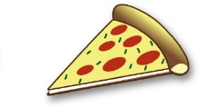 | 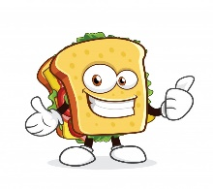  Explain to your adult how to make a sandwich. Be sure to use the words “first, then, at the end”.

