Story: “Me and My Cat”, K-1st

Instructions: Copy and paste the link to the browser. Listen to the story and answer the questions. You can draw a cat when you are finished.

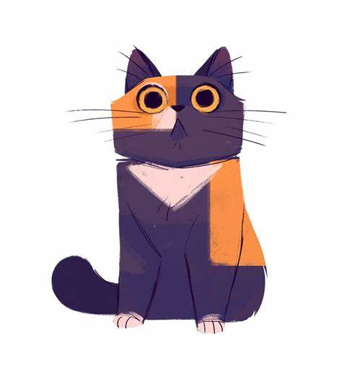
“Me and My Cat”
https://storylineonline.net/books?p=167

What animal did Nicholas turn in to?

Who do you think did that to him?

Why did Nicholas get in trouble with the neighbor’s dog?

What strange things did Nicholas do when Leonardo the cat was in control of his body?

What do you think happened to Mr. McGruff?

If you could become any animal, what animal would that be? Why?

