Story: “The Elves and the Shoemaker”, 2nd-3rd

Instructions: Copy and paste the story link on your browser. Listen to the story and answer the following questions.
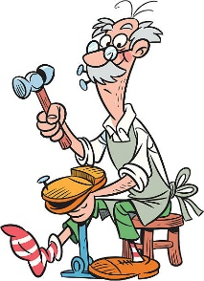
“The Elves and the Shoemaker”
https://www.storylineonline.net/books/the-elves-and-the-shoemaker/

What was happening that surprised the shoemaker and his wife every morning?

How did people react to the new shoes?

How did they discover who was making the shoes?

Order the following in chronological order:
_____ Village people made long lines to buy shoes.
_____ The shoemaker and his wife only had one piece of leather left to make shoes.
_____ The elves sneaked into the store and made shoes.
_____ The elves got gifts from the shoemaker and his wife.

Have you ever helped someone in need? If yes, how?

