Story: “Guji Guji”- K

Instructions: Copy and paste the story link on your browser. Listen to the story and answer the following questions.
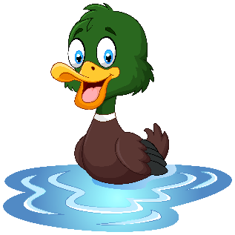
“Guji Guji”
https://www.storylineonline.net/books/guji-guji/

What is this story about?

How did Guji Guji end up with the duck family?

What came out of the third egg?

What did the three crocodiles want Guji Guji to do?

What did Guji Guji do at the end?

Why do you think Guji Guji did that?

What would you have done?

