“The Garbage Barge”, Story 3rd – 4th

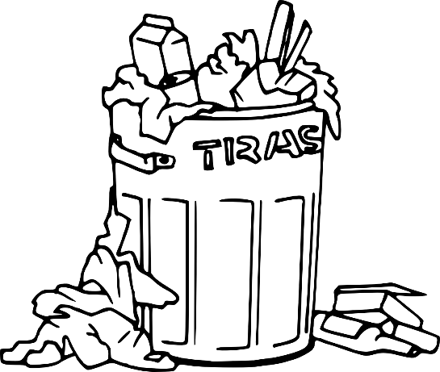
Instructions: Copy and paste the link on the search bar and listen to the story. Answer the following questions.

“The Garbage Barge”
https://www.storylineonline.net/books/garbage-barge/

What is a barge?

The captain of the Garbage Barge uses an idiom: “Well blow me down!” What does he really mean?

Where does the Captain of the Garbage Barge start his trip?

Where does the Captain of the Garbage Barge go on his journey? Name at least three states or cities.

Where does the Captain of the Garbage Barge end his trip?

Write a summary of this story. Use at least 4 sentences.

